Father’s Day Sermon
June 15, 2025
1st Sunday after Pentecost
Trinity Sunday
Morning Prayer

Sherri Matthew

Today is the first Sunday after Pentecost. It’s Trinity Sunday.

It’s also Father’s Day… How many of us here were deeply formed and shaped by our fathers? Or father figures?

My late Polish-American father, Matthew Michalski, born during the Great Depression, drafted into the Korean War, was raised a pre-Vatican II Roman Catholic. Attending Mass at St. John Kanty’s in Buffalo, NY, a grand Polish-American cathedral with stained glass and ceiling frescoes in the European architectural tradition, now closed and on the National Historic Register. In the 1930s dad attended required parochial school in 3rd grade for Catechism where the nuns gave all instruction in Polish and Mass was in Latin… A believer in God if not a supporter of the Catholic Church, Dad taught me to say my Ave Marias…

Hail Mary, full of grace.
The Lord is with thee.

In Latin… Ave Maria, gratia plena,
Dominus tecum.

In Polish… Zdrowaś Maryjo,
łaski pełna,
Pan z Tobą.
After he died, three tulips mysteriously started growing in a little cluster on our front lawn. Although we had planted tulips some years prior, the majority of them didn’t make it with our big shade trees. These three appeared the year afterwards, on the exact spot where he collapsed and was taken to the hospital by ambulance, passing away one week later. I call them “The Trinity” and they grow there every spring.

There are some things which are a mystery, that we don’t fully understand. The Holy Trinity is one of them.

A picture’s worth a thousand words… May I please direct your attention to the Holy Trinity triangle diagram on the cover of our bulletin? I could talk about the Trinity all day but some things are just easier to show than to describe with words. Take a look at this picture (I had fun coloring this on my computer, believe me!) and you can better see how the relationships among God, His Son Jesus Christ and the Holy Spirit are all interwoven.

It's intricate, it’s simple, it’s a mystery. All at once. God is the source of all.

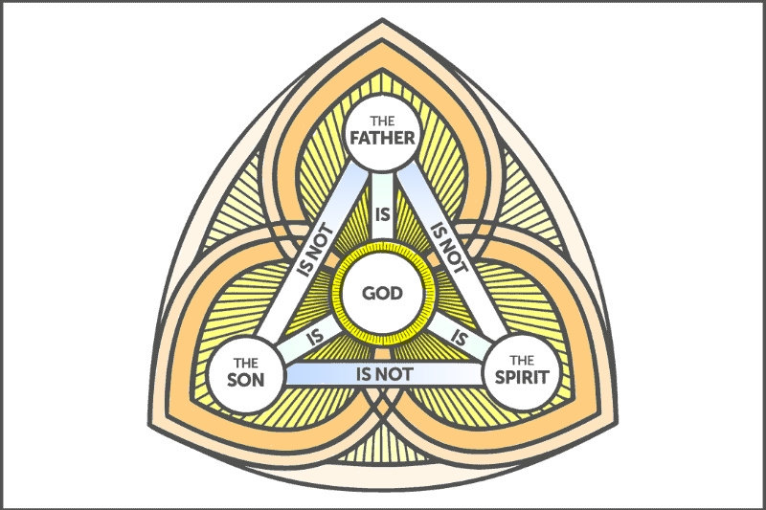

God is both father to us and Father to His Son Jesus Christ.

His Son was born here in our world… God does not have a mother or a father, as Jesus does.

God is neither male nor female; our language of faith uses the words “He”, “Him” and “Father”.

As Creator, God can also be thought of as a mother.

Jesus is also known as the Word.

God gives His Son Jesus the power to breathe and bring forth the Holy Spirit.

“It is the Father who generates, the Son who is begotten, and the Holy Spirit who proceeds.” From the Catechism of the Catholic Church.

The Holy Spirit is properly called Charity (St. Augustine). There is an outpouring of Love, finding its original source in the Father and flowing like water from Him through His Song and proceeding forth from the Holy Spirit (Who has His own love for us, being Love personified in addition to be the carrier of Love from God the Father.)

This is the essence of the three-in-one divinity: the analogy of a candle flame taken from another: “Light from Light”. The candle flame receives its light from another and does not take away from the source, but grows its own; so too does the divinity received from one Essence to another.

In baptism, The Son and Holy Spirit are sent and leave an imprint in souls: a seal given by the Son is Wisdom, the seal given by the Holy Spirit is Charity.

At baptism, we become children of the Father.

God is simple. The Holy Trinity is love.

Looking beyond an intellectual exercise of trying to comprehend the Holy Trinity – in all its intricacy and is/is nots – we can best start with the core essence of the Trinity is – love. And care and concern for us.

What does that look like? Feel like, in our daily lives?

The answer will be as unique as there are individuals, but you will surely know and feel the presence of the Trinity – God’s love, wisdom and charity – in your life when you perhaps need it most. Maybe you can even recall a few times in your life, when you became aware of the Divine Presence and He gave you peace and sustenance at a difficult time. This: God – is the ultimate loving parent.

You will grow in Communion with God.

Jesus said to the disciples, "I still have many things to say to you, but you cannot bear them now. When the Spirit of truth comes, he will guide you into all the truth; for he will not speak on his own, but will speak whatever he hears, and he will declare to you the things that are to come. He will glorify me, because he will take what is mine and declare it to you. All that the Father has is mine. For this reason I said that he will take what is mine and declare it to you." John 16: 12-15

In today’s reading of John 16 the Trinity is clearly shown in Jesus’ words: He speaks of the coming Spirit and of God the Father. He also shows how the three divine persons interact with one another, and ultimately how they engage with humanity.

Reaching out to God the Trinity in daily prayer and meditation, will help you draw closer to the life source of Love.

God our Father wants to share His wisdom, love and hope with us through His Son Jesus Christ and the Comforter, the Holy Spirit.

Since we are justified by faith, we have peace with God through our Lord Jesus Christ, through whom we have obtained access to this grace in which we stand; and we boast in our hope of sharing the glory of God. And not only that, but we also boast in our sufferings, knowing that suffering produces endurance, and endurance produces character, and character produces hope, and hope does not disappoint us, because God's love has been poured into our hearts through the Holy Spirit that has been given to us. Romans 5: 1-5

The readings today from Romans 5 speak of suffering, endurance, character and ultimately, hope. Some of our young people, especially those not yet a part of our wider Christian family, truly struggle. It is unfortunate. At a young age it may well produce character, but a loving God and a supportive church family goes a long way in providing the necessary support to make the growth of character and resilience happen.

In receiving God’s love, as parents and community leaders, we’re in a special position to help guide young people in their Christian journey, to uncover the deeper work of meditation and contemplation that brings about a greater spiritual comprehension of the Holy Trinity.

Let God’s love and wisdom be our spiritual parents, that we may be so for His Creation.

Hymns

362 – Holy! Holy! Holy! Lord God Almighty!

368 – Holy Father, Great Creator

680 – O God Our Help in Ages Past

